***Integrated Planning Policy & Regulation Action Cluster***

**Initiative ‘From Planning and Implementation to Scaling up of Smart Cities’**

***Synopsis***

Moving from smart city ‘pilots’ to mainstream fully-justified business-as-usual smart city programmes is a current necessity. Cities experience similar challenges and obstacles when implementing plans. Providing structure that helps to assess what is common and transferrable; and offering practical guidance material can substantially help build confidence, and accelerate the uptake of more common smart city solutions.

The goal of this initiative is to co-create a **Smart City Guidance Package (SCGP)**. This will support the implementation and design of smart city strategies and plans by making best use of capacity and by sharing knowledge and experience. Moreover, it will capture and develop practical tools to support the implementation of smart city strategies.

***How we are going about things***

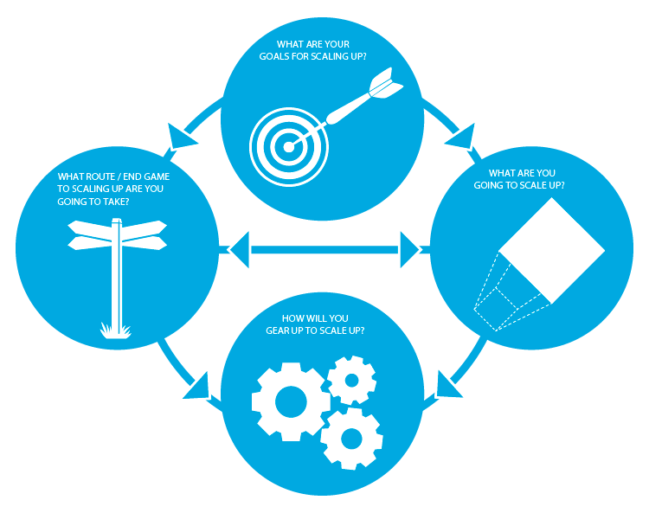The initiative is built out of ~15 EIP commitments from cities, industry, finance, research sectors and city networks. Smart City projects and initiatives such as CELSIUS, STEP-UP, TRANSFORM, SCIS, CityKey, Lighthouse Projects are also involved.

To date we have:

* categorised common pathways and obstacles (from the legislative end, pitfalls, solutions, funding possibilities, definition of common steps, and the like) in Smart City.
* Identified and captured relevant references
* Structured and outlined the beta version of the SCGP

***Going Forward***

Three principal activities are planned:

1. Finalisation of the SCGP
2. Dissemination of solutions and best practices among cities
3. Replication of success stories

***Integrated Planning Policy & Regulation Action Cluster***

**Initiative Tools for Decision Making, Management and Benchmarking**

***Synopsis of the project***

To monitor gaps with available tools and define appropriate KPIs and the relation with standardisation issues.

This initiative focuses on the identification of city decision makers’ needs to enter into a smart and sustainable program for their city or community. It brings together various EIP commitments addressing these issues, expressing a need for tools (i.e. initial “standardised” audits, set of best practices and success stories, integrated planning and follow-up of action plans, management related methodologies and guidance, methods for data collection, analysis and reporting for a follow-up of actions’ efficiency then improvement/management system approach). It analyses existing KPIs and identifies needs for additional ones, including how to measure and collect data in such a way that comparison would be possible for replication and reporting purposes. Finally, it explores what kind of appropriate standardisation-related work could be proposed or launched to better and more systematically meet the objectives.

***The main successes to date***

Work has been done to align KPIs categories from major initiatives and standardisation development, achieving agreement on **5 major themes**:

* 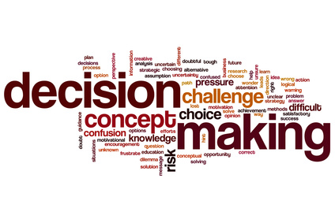PPPGR – People, Planet, Prosperity, Governance, Replication & Scalability

In addition, agreement achieved on **4 main KPI categories**, covering KPIs for:

* Decision Making & investing
* Program Management & Evaluation (Improvement)
* Project Evaluation-benchmarking
* Reporting and Communication

The initiative has contributed to the drafting of the Smart Cities Guidance Package, detailing KPIs and Benchmarking Tools to be consistently used at the project level by cities.

***Planned actions***

Five areas of action foreseen:

1. Finalise the ***Smart Cities Guidance Package*** in collaboration with the initiatives of the Action Cluster Integrated Planning Policy and Regulation’s initiatives.
2. Finalise the **sets of KPIs** and test them in real cases (EU projects, cities and communities - partner initiatives networks, e.g. SCC01s, European energy award, SCIS, Citykeys, Eurocities)
3. Feed the KPIs data base for **benchmarking**
4. Inform European **standardisation** work and discuss global KPI-related existing standards
5. Coordinate **standardisation** needs from EIP-SCC initiatives

***Integrated Planning Policy & Regulation Action Cluster***

**Initiative ‘6-Nations Smart Cities Forum’**

*‘Establishing a competitive national market context’*

Smart cities progress will be inhibited without an enabling market environment in place. This initiative works with Europe’s 6 leading and/or large Member States to compare and share strategies, policies, and programmes; and package up resulting good practices. The limited group of nations is a conscious step to ensure that authentic open and trusted discussions take place. A rhythm of workshops and calls have taken place since the launch workshop in April 2014. 6-Nations members include: AT, DE, ES, FR, NL, UK.

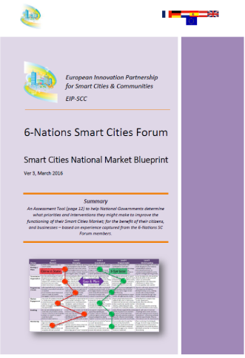***The 6-Nations Smart Cities Blueprint***

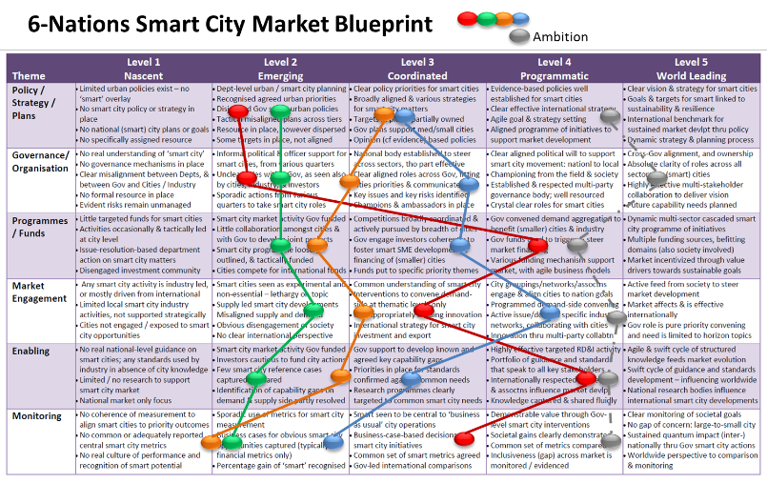A Blueprint has been delivered. It includes a pragmatic assessment tool that addresses six themes where nation state level actions are essential. These include:

* Policy/Strategy/Plans
* Governance/Organisation
* Programmes/Funding
* 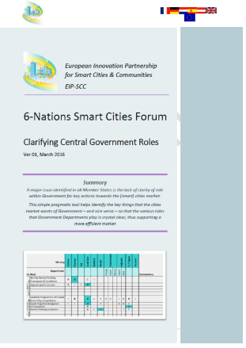Market Engagement
* Enabling
* Monitoring

Practices and experience continues to be shared across all these themes, and good practices continue to be captured and shared in order to learn and improve from each other’s experiences.

In addition, a pragmatic tool has been delivered that clarifies which Government Department holds what form of role, for the priority activities where cities seek guidance from Central Government. This is intended to clarify accountabilities and help ‘break down silos’.

***And more to come…***

A further list of 10 potential areas of collaboration have been identified and plans are being developed to address these topics by bringing experts together from each of the 6-Nations members where these topics are viewed as being a priority. These include topics like: Standards strategies; Maximising the effectiveness of City Networks; Capacity development; Data; Urban Infrastructure and investment performance; Replication of smart city solutions beyond the EC / National grant-funded cities; and International strategies (eg China, US, India).

***Expanding the learning in the market***

Work will continue within the 6-Nations group. Deployment across other natural Member State groupings is desired, to improve Europe’s overall competitiveness.

**AC 20th June - Individual Workshop**

***Participants***

25 participants and 5 guest speakers.

***Objectives***

* Feed the EIP SCC Smart City Guidance Package with feedback received during the Workshop
* Gather input on cities’ needs for making good quality urban plans as well as on the latest development and agreed KPIs categories, sub-categories
* Collect innovative solutions for the policy guidance package (SCGP)
* Share initiatives’ developments in an attempt to align KPIs

***Outcomes***

1. Finalisation of the SCGP to be published in October
2. Alignment on set of KPIs to be used EU-wide by city projects, taking into consideration the UN SDGs framework

***Input***

1. **Cities**:  needs of the cities for implementing good smart city projects. In particular, the aim is to collect information on 1) how cities define their implementation strategy; 2) how they choose a site for implementation; 3) how they select specific smart city solutions; 4) how these solutions are adjusted and made suited to the situation and context of the city; 5) how they deal with funding.
2. Input and alignment on ongoing priority actions and on how to meet EU targets (standardisation)
3. Feedback on the proposed content of the intermediate version of the Smart City Guidance Package by all participants